Hw 2 Tetris Tetromino

- By Shaunak Patel

The first thing we had to do was to import all the things that were required to complete the code that is import color, graphics, graphics 2d, rectangle2d, random, jcomponent, BasicStroke (for border).

Then I created a constructor where I declared all the integer values I need for the code. I approached this assignment using the coordinates so I had to declare all the integer values.

Then I started creating all the Shapes (I , J , L , O , S , Z, T ) using the integer values.in which I also filled colored which I picked randomly and also gave a border using SetStroke and color of border as black, I also created random border color code which I commented out .

Then I made a Tester where I created a frame of Size (600,700) with the help of import Jframe. And also gave Close operation and title of the frame.

Outputs of the code:

I SHAPE

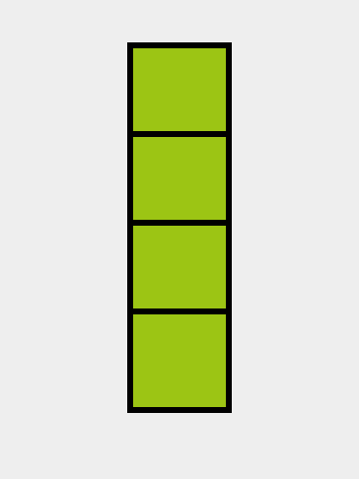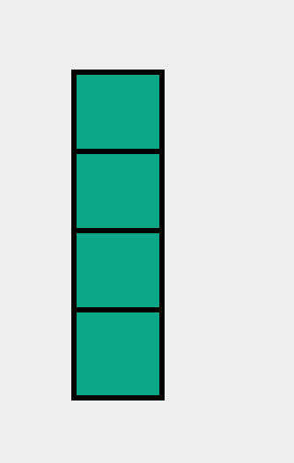

J SHAPE

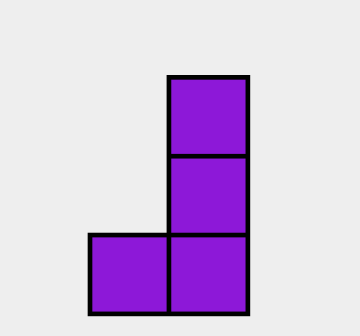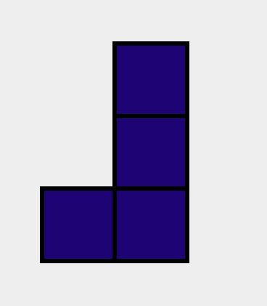

L SHAPE

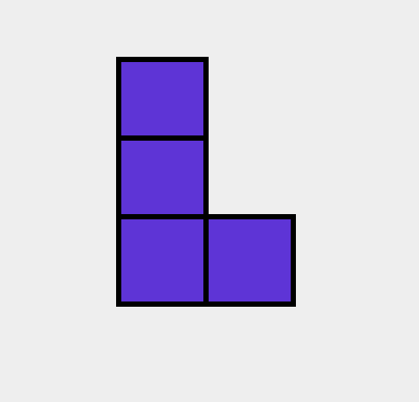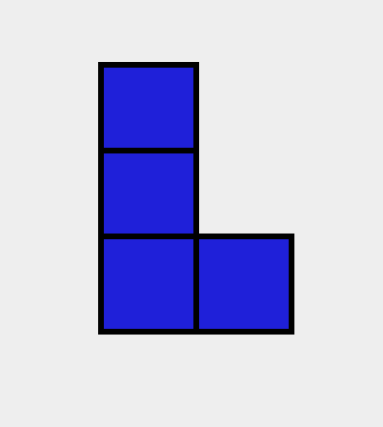

O SHAPE

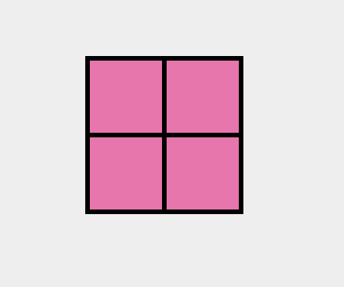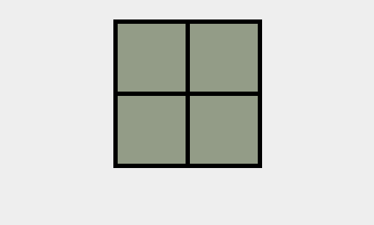

S SHAPE

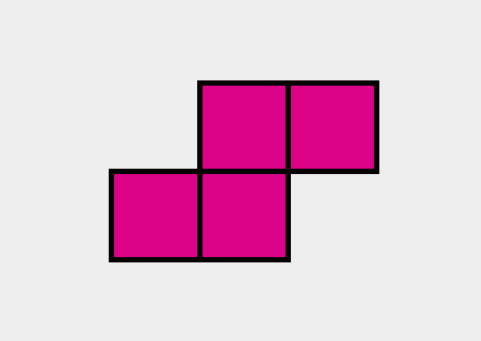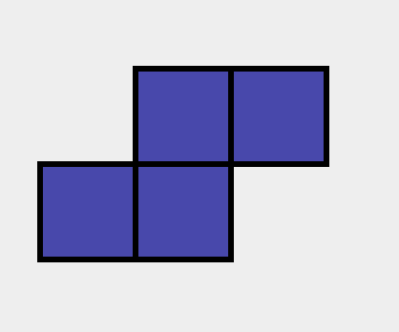

T SHAPE

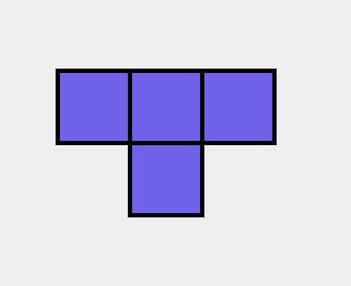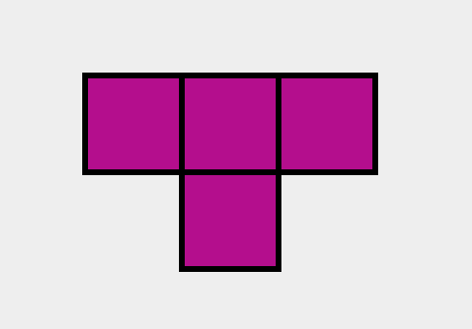

Z SHAPE

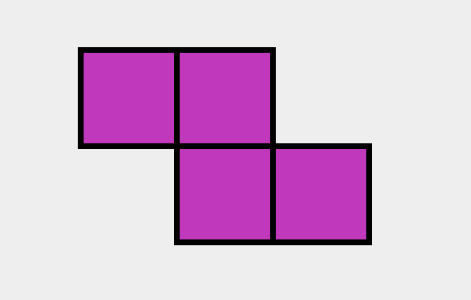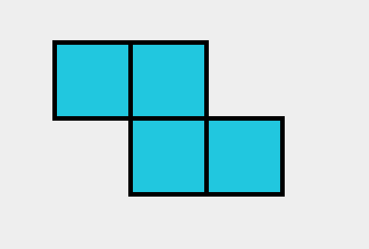

Overall It was an assignment because we had already did an assignment in the lab but I had a hard time with all the random things because my shapes were moving continuously when I run the code. The problem with my code was, I was running the random things inside the Paint component so it made my shapes moves each time run the code. The solution I found out was that I just moved all the random things I called outside the Paint component which made it stop moving.